**Selenium Automation Framework(with Java)**

**Author - Chitrakala**

**Tech Stack of Web Automation**

Programming - Java ( JDK > 22, IntelliJ)

User Interactions, browser Automation Selenium

Test Framework -> TestNG

Build Management -> Maven

Reporting - Allure Report, Extent Report.

Data Driven - DDT Apache POI.

CI / CD -> GIT, Jenkins

Coding Best Practice- SonarLint

Logs - Log4j

Remote Selenium Grid - Cloud Grid, Selenoid

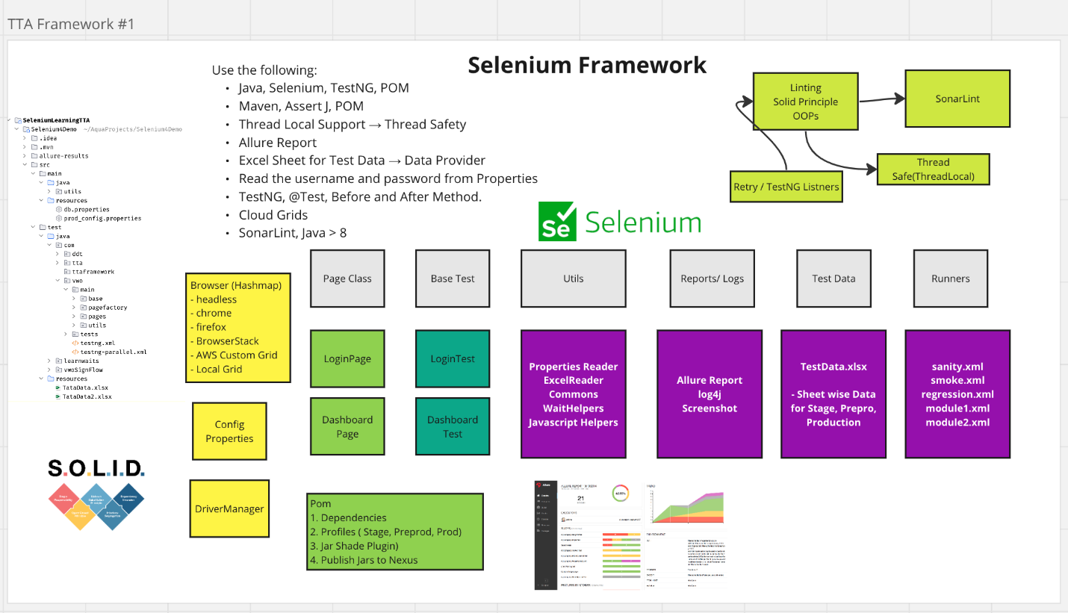

[](http://localhost:63342/markdownPreview/976984673/markdown-preview-index-1386972864.html?_ijt=5h03fac6oech96vekbp7h5i8o3)mvn test -Dsurefire.suiteXmlFiles=testng.xml

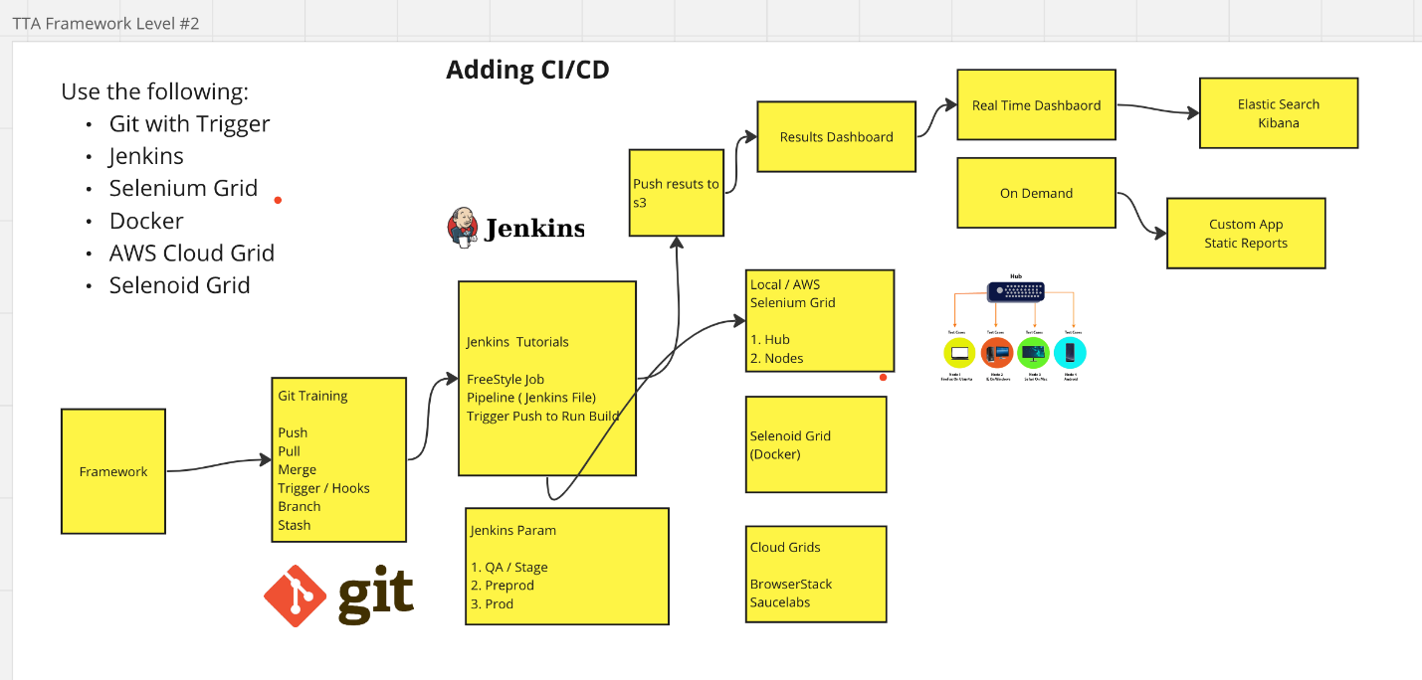

**Seleniod - Docker Grid Running**

* Selenoid is a powerful tool for running Selenium tests in Docker containers.
* which can help you manage and scale your test automation infrastructure more efficiently.